II. Sequential Logic Design

Problem Set #2.
Assigned 18 September 2006, Due 20 September 2006

Comparator. A sequential circuit has two inputs and two outputs. The inputs (X1 X2) represent a 2-bit binary number, N. If the present value of N is greater than the previous value, then Z₁ = 1. If the present value of N is less than the previous value, then Z₂ = 1. Otherwise, Z₁ and Z₂ are 0.
- Derive a Mealy machine state diagram and write the Behavioral Verilog. (Hint: The machine needs only five states).
- Derive a Moore machine state diagram and write the Behavioral Verilog. (Hint: The machine needs at least eleven states).

Verilog Specification of a Bit Serial Adder. You already know about parallel adders. Your task is to specify in behavioral and structural Verilog, a bit serial adder. Such a system, built around shifters and a single bit full adder, works by shifting in the bits to added, one at a time, forming the sum of those bits, one at a time. The basic structure of the system is shown below implementing S[3:0] = A[3:0] + B[3:0].
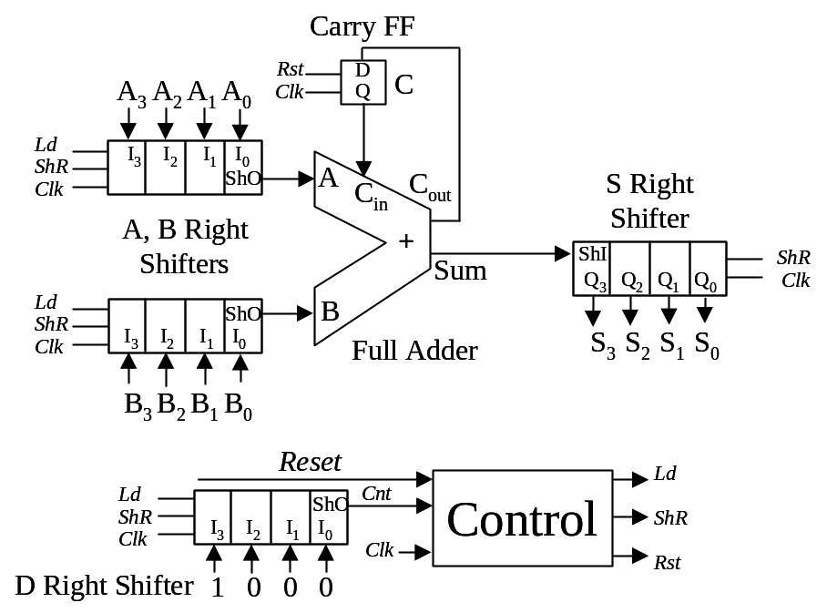

Control signals are in italics, and data flows are arrows. Reset and Clk are control signals. The inputs to the adder are A, B, and C_{in}. Its outputs are Sum and C_{out}. The shifters have parallel load inputs I[3:0], serial shift right input ShI, parallel outputs Q[3:0], and serial shift right output ShO. They read the parallel inputs on the positive edge of the clock when Ld is true, and shift right on the positive edge when ShR is true. They shift in ShI and shift out ShO. Ld has priority over ShR if both are asserted at the same time. Also on the positive edge of Clk, the Carry Flip Flop C is reset to 0 when Rst is true. It loads C_{out} otherwise.

Write behavioral Verilog for the following components:
- Carry Flip Flop
- Right Shift Register
- Full Adder

The D shifter is initialized to 4’b1000 when LdD is true. When the 1 shifts through to the output Cnt, it is a signal to the Control that four cycles of single bit addition have been executed.

The system works as follows. The Reset signal is asserted for exactly one clock period. On the first rising clock edge with Reset true, the Control enters the Initialize state and asserts the control signals Ld and Rst. On the next rising edge, with Ld and Rst true, the system loads A[3:0] into the A shifter, B[3:0] into the B shifter, 4’b1000 into the D shifter, and 0 into C.

At the same time, the system enters the Add state. Shortly after entering the Add state, A[0] and B[0] become visible to the adder’s inputs, with C_{in} = 0. After a further propagation delay, a single Sum bit S[0] and a new C_{out} are formed. With the control signal ShR set to true, the shifters are set to shift to the right on the next clock edge.

On this next edge, the shifters actually shift to the right. S shifts in the 0th sum bit and C receives the previous C_{out}. After a short delay, A[1] and B[1] appear at the shift right outputs of A and B, and the previous carry is now at C_{in}. After a further propagation delay, S[1] is formed with a new C_{out}..

The process repeats for A[2] + B[2] at the next rising edge, and A[3] + B[3] at the following rising edge. At the same time, D has a 1 on its right shift output, indicating to the control that the last bits have been added. The next transition takes the machine to the Last state, with one final shift right to catch the A[3] + B[3] sum in S[3].

Complete a sketch of the system’s timing using the diagram below as a start:
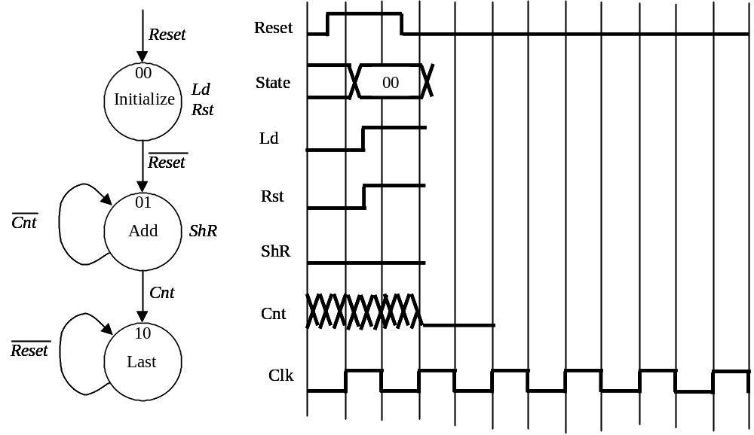
- Write the Behavioral Verilog for the Control

Protocol. Consider the design of two communicating Finite State Machines MASTER and SLAVE. The master FSM asserts its output GO when it wants the SLAVE FSM to begin processing. The SLAVE FSM asserts its output DONE when it has completed processing. The MASTER keeps asserting GO until it detects that done is asserted. The SLAVE keeps asserting DONE until it detects that GO is no longer true, and returns to a configuration to await the next asserted GO signal.
- Draw as simple state diagrams for an all MEALY MACHINE and all MOORE MACHINE implementation that captures the signaling protocol between MASTER and SLAVE FSMs. Don’t worry about exactly what the SLAVE does between GO and DONE; just assume that there are several states there eventually leading to the sequence of states that generate the DONE handshake.
- Draw the timing diagrams for a complete GO/DONE sequence for the two different implementations approaches. Assume a common clock for the MASTER and SLAVE, and include this signal in your timing diagrams.
- Will your solution still work if the MASTER and SLAVE operate with different clocks? Illustrate your answer with a modified timing diagram with independent clocks and explain why or why not.
- Is your answer to question 2(c) any different if the SLAVE clock is an exact, synchronous multiple of the MASTER clock (e.g., the SLAVE runs twice as slowly as the MASTER, but its clock is synchronized with the MASTER clock).
- Write the Behavioral Verilog for the situations (a), (c) and (d)

Cockroach Brain. In this exercise you are going to build a cockroach brain by means of a Finite State Machine in order to successfully bring the cockroach out of a labyrinth (Figure below).

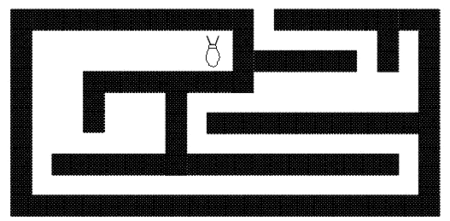

The cockroach has two sensors in his antennas, one in his left antenna and one in his right antenna. If an antenna touches something the cockroach receives a logical one; and receives a zero in the other case.
The cockroach has three actuators, one for forward step, one to turn left slightly (1 degree) and one to turn right slightly (1 degree).
The goal as we said is to make our cockroach smart enough to get out of the maze.
The set of behaviors can be described in the next figure, these are the situations cockroaches know how to deal with.

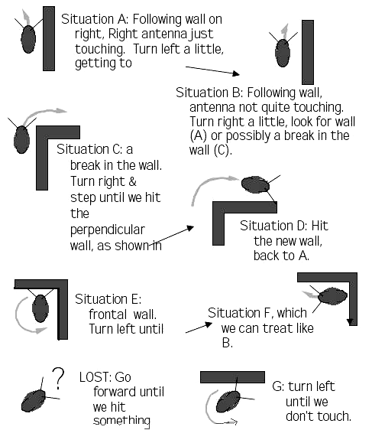

- Build the state transition diagram of the Cockroach’s brain
- Write the Behavioral Verilog for the FSM that behaves like is desired.

Hint: The strategy is to keep the wall on the right.

Memory manager. In this exercise is continued the problem presented for combinational logic about memory management but now the design of the sequential block is needed (figure below). The main task of this block is to perform the control for two operations named: allocate and free as is explained:
  - Allocate. In this operation the client is asking to the control for memory allocations by means of the signal REQUEST and indicating the number of memory allocations by means of REQUEST_NUM. After receiving this signals, the sequential block gives to the combinational block a vector S with the status of the memory block (this vector indicates which memories are free in this moment) and the number of memory allocations needed (REQUEST_NUM). And the combinational block generates the vector V containing the allocations that are assigned. After that the sequential block refresh its vector S of status of the memory allocations (have to be indicated in this vector the memory allocations that were assigned as busy) and gives to the client the vector V containing the memory allocations assigned it activates the signal ACK indicating that the operation was completed.
  - Free. In this operation the client is asking to the control to free some memory allocations. In this situation the Client indicates to the sequential logic block this operation by means of the REQUES signal the vector V (this vector contains the memory allocations that the client wants to free). With this information the Sequential logic block refresh its vector S of status and after that send the signal ACK to the client indicating that the operation was completed.

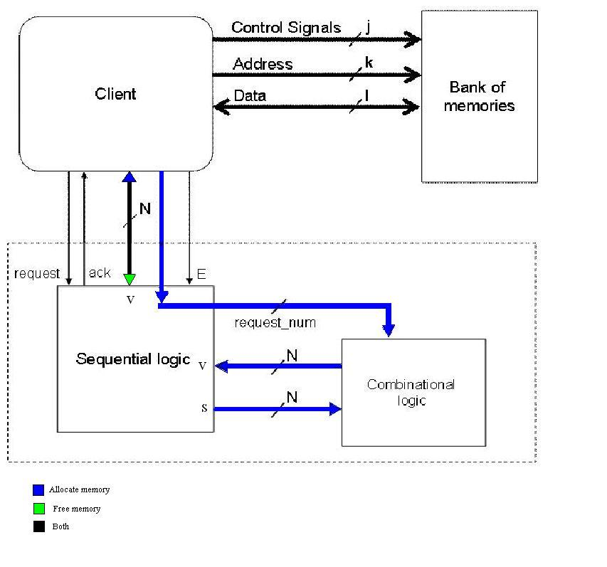

- In the Fig. 3 there is a signal E that could be used as enable of the sequential logic. You could or couldn’t used it, it is your choice but explain why.
- Design the circuit that behaves like is desired for the sequential logic block
- The design of the point 2 should be coded and verified in Verilog

III. Memories, Arithmetic Devices and Op. Amp.

